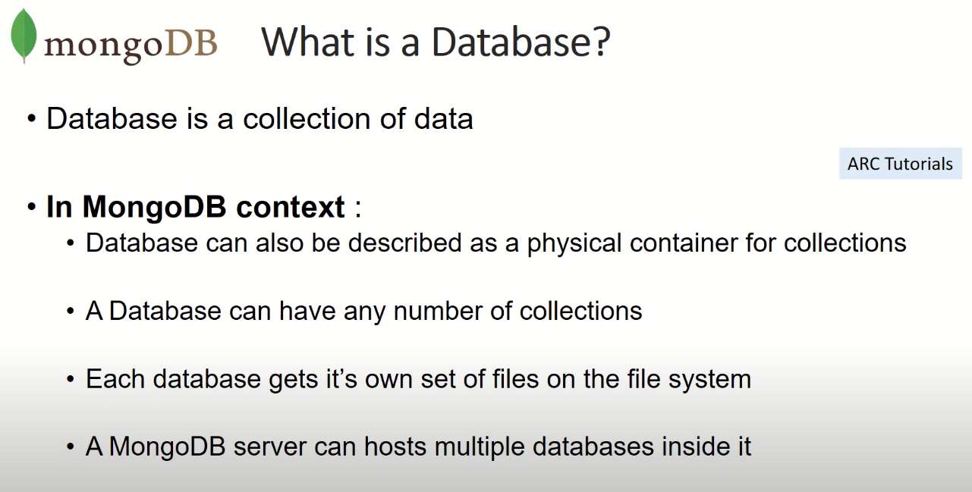

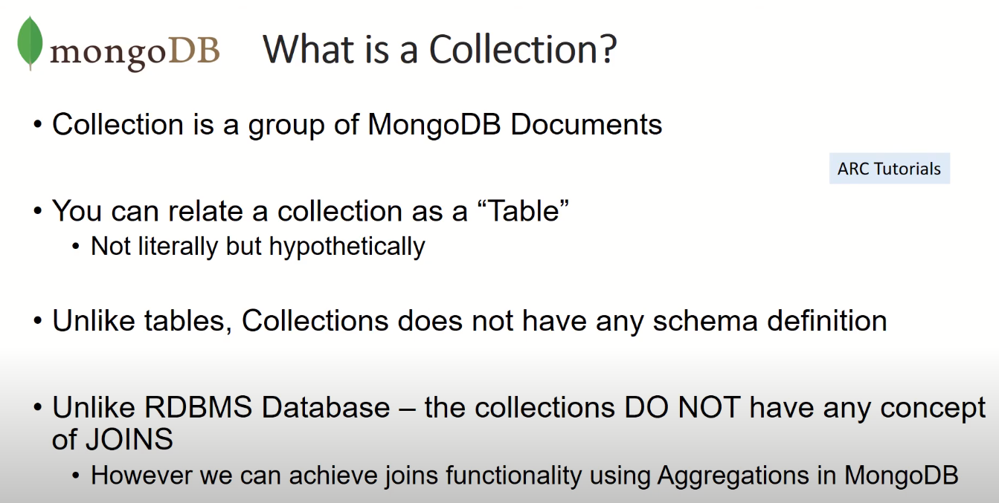

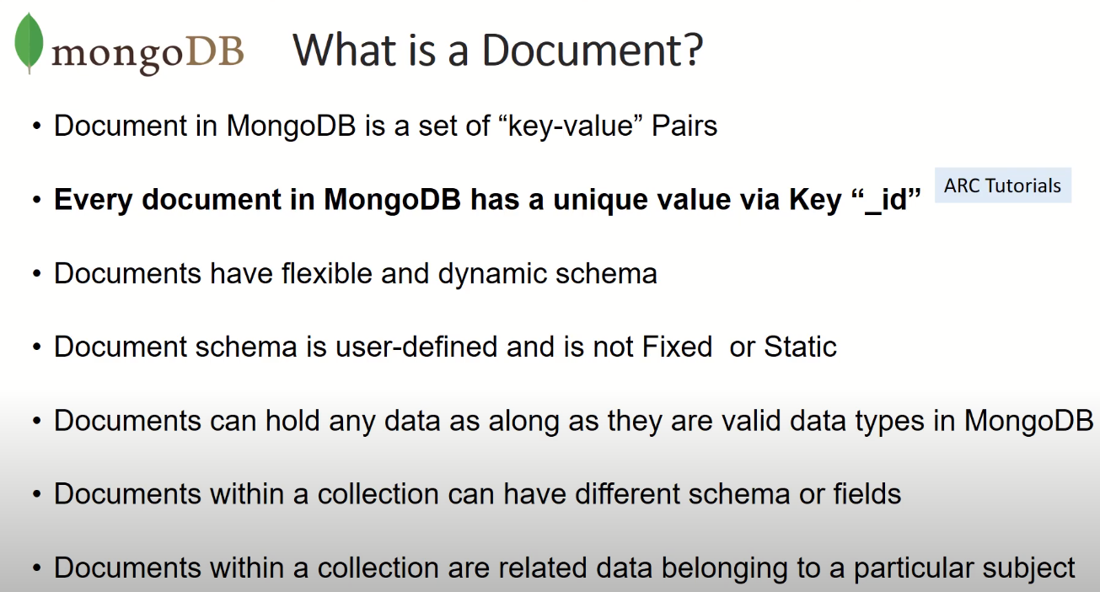

RDB:

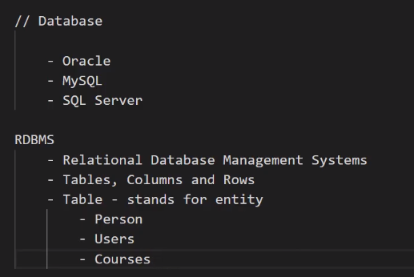

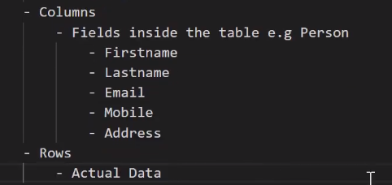

MongoDB

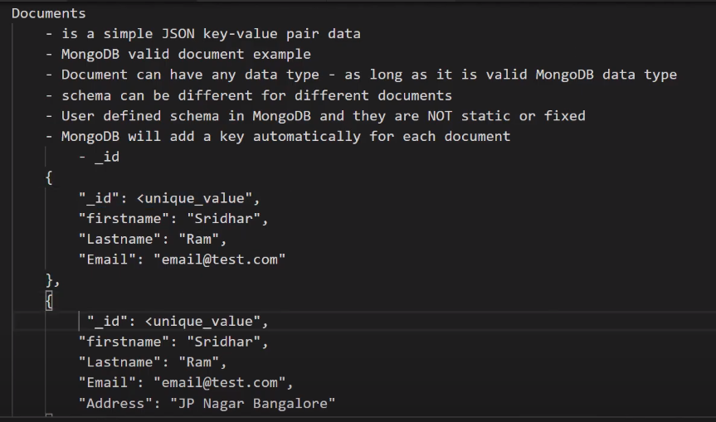

Documents can have a different value pair, the second document have an address, Schema in MongoDB are not static.

MongoDB will add a key automatically for each document: _id

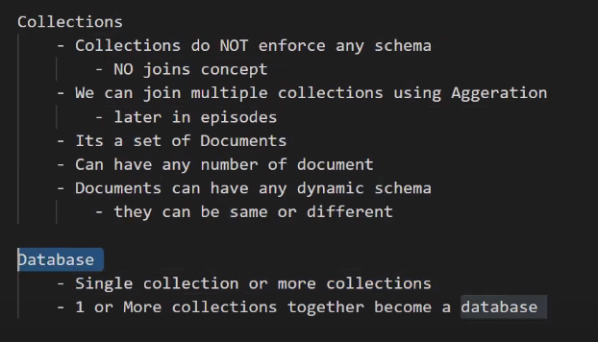

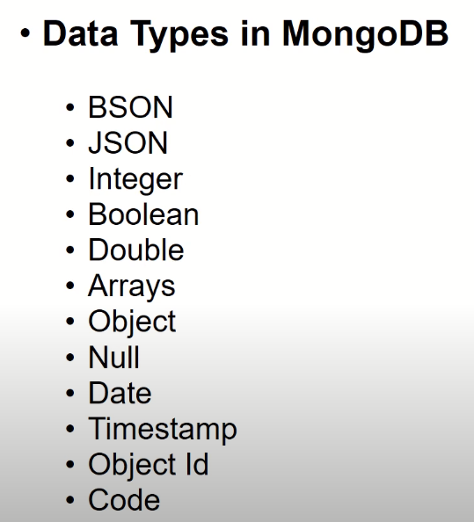

<https://www.javatpoint.com/json-vs-bson>

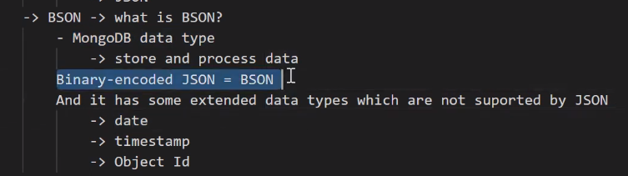

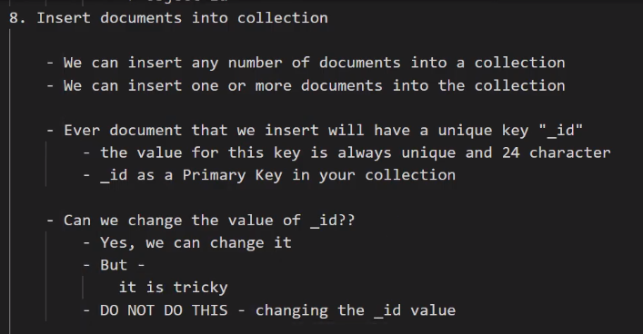

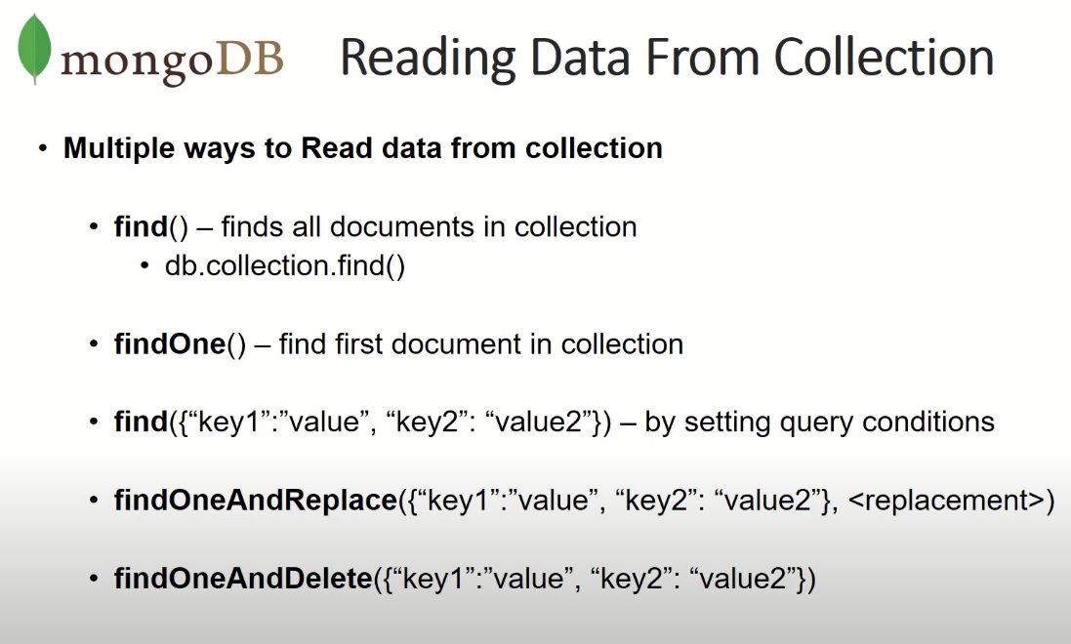

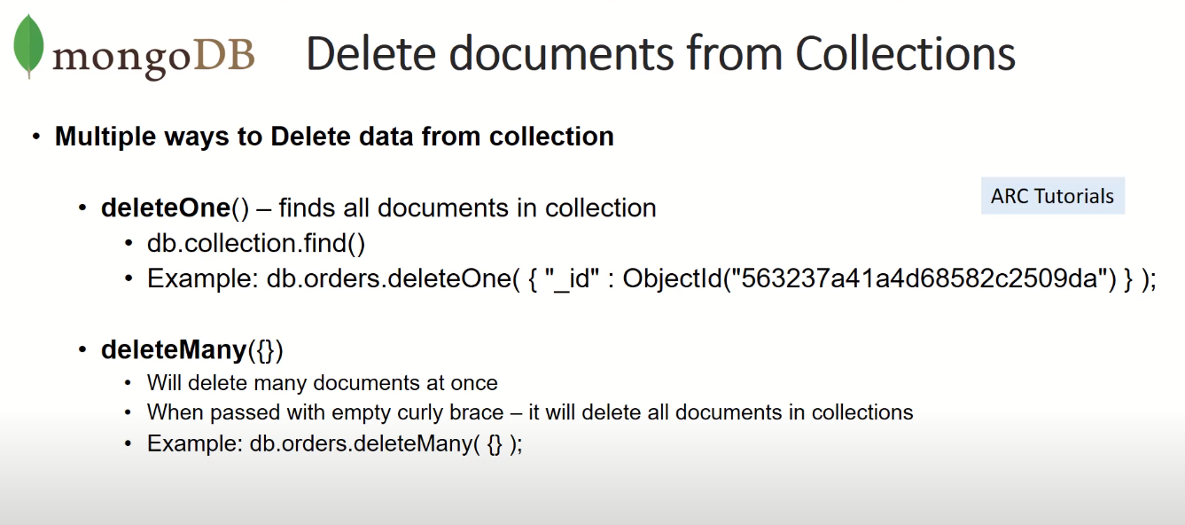

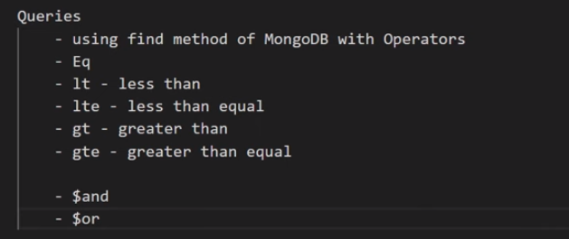

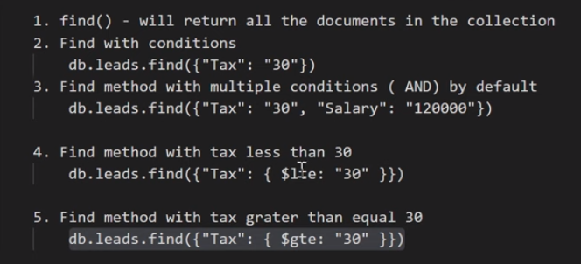

**For example hotels with 2 bathrooms and more or equal 8 beds:**

**db**.**getCollection(**"collection"**)**.**find({**$and **:[** **{**"bathrooms"**:** 2**},{**"beds"**:{**$gte**:**8**}}** **]** **})**

change to or condition:

**db**.**getCollection(**"collection"**)**.**find({**$or **:[** **{**"bathrooms"**:** 2**},{**"beds"**:{**$gte**:**8**}}** **]** **})**

Show only the name of all the fields:

**db**.**getCollection(**"collection"**)**.**find({},{**"name"**:**1**})**

Show everything but not the name of all the fields:

**db**.**getCollection(**"collection"**)**.**find({},{**"name"**:**0**})**

Show beds, name, summary for all places with less or equal to 4 beds:

**db**.**getCollection(**"collection"**)**.**find({**"beds"**:{**$lte**:**4**}},{**"name"**:**1**,** "summary"**:**1**,** "beds"**:**1**})**



